God's Pharmacy is Amazing!

It's been said that God first separated the salt water from the fresh, made dry land, planted a garden, made animals and fish... all before making a human. God made and provided what we'd need before we were born. These foods are best and more powerful when eaten raw. God left us a great clue as to what foods help what part of our body!
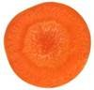 | A sliced Carrot looks like the human eye. The pupil, iris and radiating lines look just like the human eye... and YES, science now shows carrots greatly enhance blood flow to and function of the eyes.
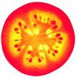 | A Tomato has four chambers and is red. The heart has four chambers and is red. All of the research shows tomatoes are loaded with lycopine and are indeed pure heart and blood food.
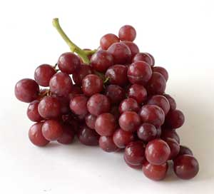 | Grapes hang in a cluster that has the shape of the heart. Each grape looks like a blood cell and all of the research today shows grapes are also profound heart and blood vitalizing food.
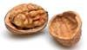 | A Walnut looks like a little brain, a left and right hemisphere, upper cerebrums and lower cerebellums. Even the wrinkles or folds on the nut are just like the neo-cortex. We now know walnuts help develop more than three (3) dozen neuron-transmitters for brain function.
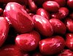 | Kidney Beans actually heal and help maintain kidney function and yes, they look exactly like the human kidneys.
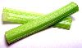 | Celery, Bok Choy, Rhubarb and many more look just like bones. These foods specifically target bone strength. Bones are 23% sodium and these foods are 23% sodium. If you don't have enough sodium in your diet, the body pulls it from the bones, thus making them weak. These foods replenish the skeletal needs of the body.
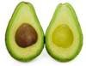 | Avocadoes, Eggplant and Pears target the health and function of the womb and cervix of the female - they look just like these organs. Today's research shows that when a woman eats one avocado a week, it balances hormones, sheds unwanted birth weight, and prevents cervical cancers. And how profound is this? It takes exactly nine (9) months to grow an avocado from blossom to ripened fruit. There are over 14,000 photolytic chemical constituents of nutrition in each one of these foods (modern science has only studied and named about 141 of them).
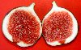 | Figs are full of seeds and hang in twos when they grow. Figs increase the mobility of male sperm and increase the numbers of Sperm as well to overcome male sterility.
 | Sweet Potatoes look like the pancreas and actually balance the glycemic index of diabetics.
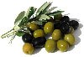 | Olives assist the health and function of the ovaries
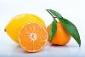 | Oranges, Grapefruits, and the Citrus fruits look just like the mammary glands of the female and actually assist the health of the breasts and the movement of lymph in and out of the breasts.
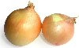 | Onions look like the body's cells. Research shows onions clear waste materials from all of the body cells. They even produce tears which wash the epithelial layers of the eyes. Garlic also helps eliminate waste materials and dangerous free radicals from the body.

